* 
* Adding column names …
* 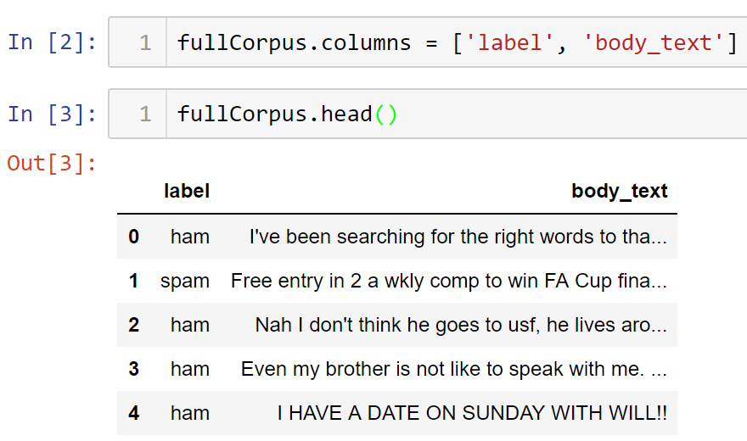
* Explore the dataset
* 1. What is the shape of the dataset?
* 2. How many spam/ham are there?
* 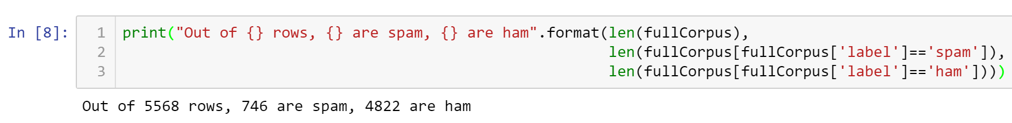
* 3. How much missing data is there?
* 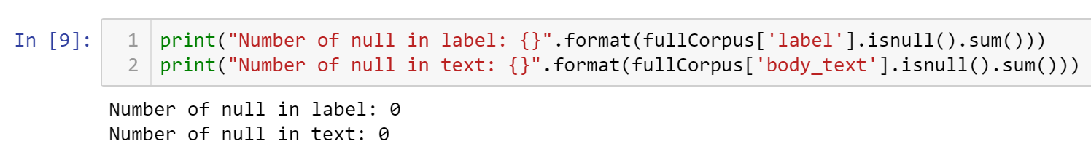
* Fortunately, no missing data.
* This exploration help dictates how we approach the data modeling and analysis.
* Place your name at the bottom of your code, download your Python program in html format, and submit your work in Canvas.